Zadanie 6 - Particle Swarm Algorithm

Michał Darowny, 210957

1. Task

The task for this exercise was to create particle swarm algorithm implementation as TCP service. To run, one needs to start this algorithm by starting the Server class and then Client class. Graphs are produced using Jzy3D library.

1. Particle Swarm Algorithm

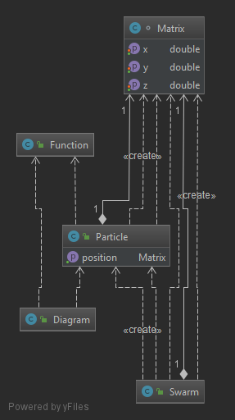

Figure 1. Classes and their properties.

Main idea was to have Swarm class which performs all needed operations and uses Particle class as agent in the algorithm, as PSA is based on positions the matrix class which is additional class that stores position in x,y,z coordinates. Class function stores function which were used for optimisation and to define type of particle. It was needed for marking position of the particle as well as other algorithm calculations in the main Swarm class. Diagram class is used to graph a found minimal value and the function for which the optimisation was performed.

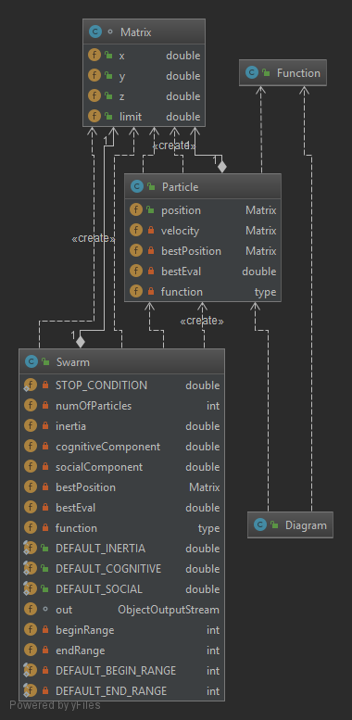

Figure 2. Fields of the classes in the Algorithms package

Matrix has position of x,y,z and the limit field is maximal value as starting random position has to have maximal value. Particle beside position in the form of Matrix need to have velocity and other parameters for evaluating best option.

As algorithm moves randomly particles the value of function for each particle position is checked. If function’s value at the new position is lower than that the previous position it is added as bestPosition. The best eval is global best evaluation- lowest point between all particles.

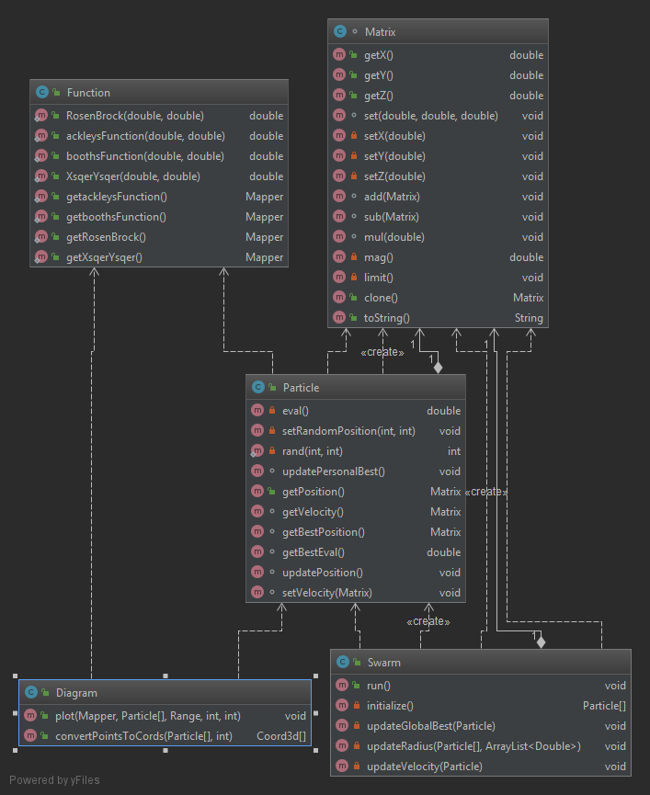

Figure 3. Methods in the classes with constructors

Matrix has basic get( ) and set() also add() sub() and mul() add basic operations mag() and limit() are for finding magnitudes and limit() is for scaling values of magnitude.

Function passes positions x,y as doubles and allows to calculate values of the function at that position the get methods of function return mapper - jzy3d.plot3d.builder class which is used to mapping position values to function values to then prepare coordinates for the Diagram and thus allow plotting the function. Swarm the main algorithm class performs all needed operations to find minimal values of the function. It initializes the array of particles with random position between given ranges, each consecutive loop you find values of function for each particle’s position and search for the minimal value. Sets oldEval as bestEval which is used for comparison, particles update their personal best if their evaluation is smaller than bestEval. As each particles hold information about bestEval they can get closer and closer to the minimum if their positions are changed each loop provided that the value we change to is smaller than the previous one. So to do that we start particles with random velocity, particle position is updated according to velocity it has and velocity is updated by formula where three coefficient affect the outcome. Firstly velocity is multiplied by inertia coefficient (Fig 2 fields) then value of best position (position for which there was minimal value of given particle)is multiplied by cognitive component coefficient and by some random value then to velocity is added position which is multiplied by socialComponent coefficient (figure 2.) and another random value.

1. Server-Client communication.

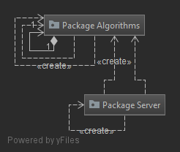

Figure 4. Server usage of the Algorithm

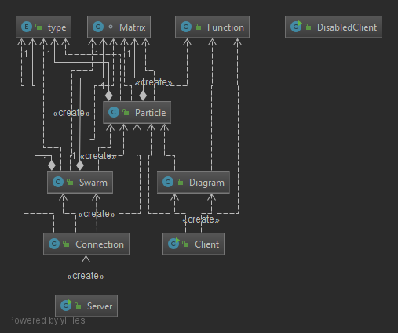

Figure 5. Connection class dependence on algorithm.

Connection starts the Swarm when proper request from clients are sent. Server listens for new client and for each of the new connected Clients it creates Connection for it (Thread) . Disabled Client was used to check if parallel sending and connection was possible -threads test.

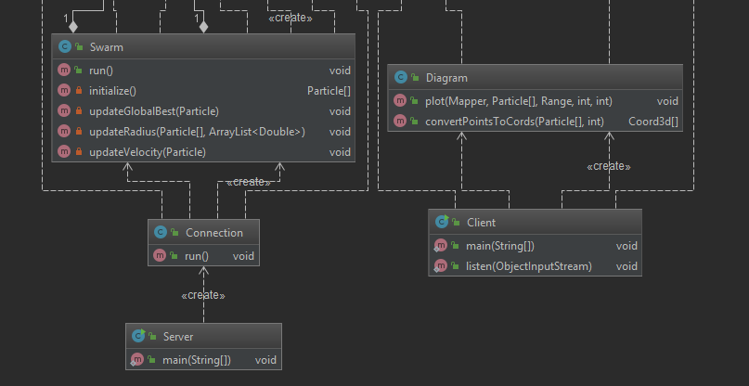

Figure 6. Methods and constructors in the Server Client part of the application.

Client starts its own thread listen() to listen for informations sent by Swarm and Connection. And as the Swarm operates it sents most important info to the Client. After Stop condition is met Swarm sends the particles list so that client using Diagram can plot them and the function which was being optimized.